Rstudio Cloud to Rstudio computer

1. Login to Rstudio Cloud and open up the project you want to move to your own laptop (e.g. Analysis_Plan)
2. In the bottom right corner, select the files you wish to transfer – I recommend selecting everything, which you can easily do by checking the box that the arrow is pointing to below

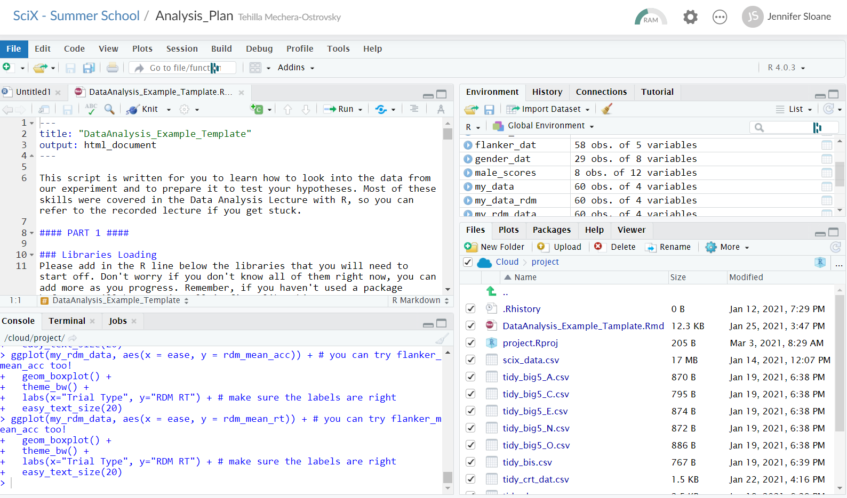

1. Once all the files are checked, navigate to “More” and select the dropdown option that says “Export…”

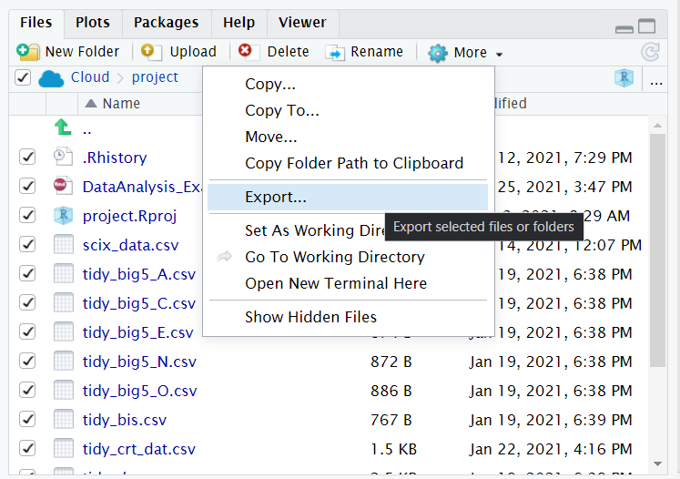

1. You can rename your file (see example below) and then click download

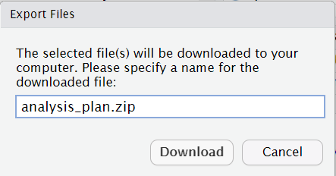

1. Your file will download to your local computer as a zip file
2. Open the zip file and you’ll see all the files
3. Make sure to move these files to a new folder in a location you’ll remember and be able to easily access
4. Repeat this process for any other Rstudio Cloud project you want saved to your local computer (e.g. BasicBasics, CleanItUp)

**\* If you run into problems installing Rstudio on your computer, check out these useful tutorials on “running R on your own computer”:**

<https://www.youtube.com/playlist?list=PLRPB0ZzEYegOZivdelOuEn-R-XUN-DOjd>